The Necessity of Revelation

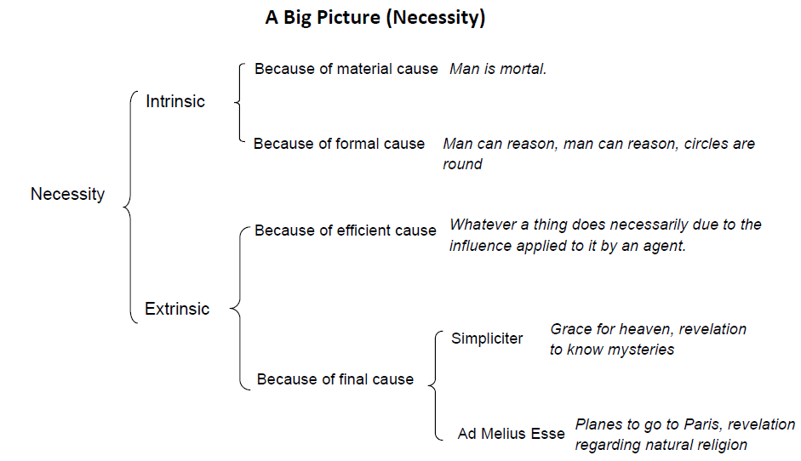
Revelation’s necessity is that of final cause.

Proposition 1: Supernatural revelation is not absolutely necessary (according to the nature of God or the nature of man)
- God is a free, intellectual being – not required to provide revelation.
- Man’s nature cannot require something above his nature.
- Man is able to know certain things about God, and if his end is a natural one, he would be able to know at least the essentials by reason, without any revelation.
  - The existence of God
  - God is rewarder of good and punisher of evil.
  - Man’s obligation to worship.
    - Indeed we find these ideas existing universally in human history, though with deviations and corruptions.
  - Likewise, the primary principles of the natural moral law.
    - Not to kill, steal, commit adultery, etc.

Proposition 2: Revelation is morally necessary for a suitable knowledge of natural religion.
- “suitable”
  - Somewhere btw the bare minimum to reach the natural end and perfect knowledge
  - Fairly complete
  - Certain – without guesswork or errors
  - Accessible – one can attain this knowledge early enough in one’s life to be able to use it to govern the greater part of that life
- In this series, we have already seen the naturally attainable knowledge of God, we’ve seen the duty of religion.
  - But looking at human history, we see precious few who have attained to much of this truth only through reason.
  - The majority of human beings and even a great many cultures have no philosophy.
  - Even in those places where there were philosophers, how influential was their teaching?
  - Ancient Greece is rightly regarded as the pinnacle of unaided human reason in its philosophical exploration – the greatest of the Greek philosophers achieved a rather remarkable knowledge about God and duties toward Him.
  - But there is a long process of speculation – some 200 years of real philosophy before we get to Plato and Aristotle.
    - And even they had some errors mixed in with the truth they came to know.
      - Plato supported wives and children being held in common by all men, for example.
      - Aristotle defended scandalous images of gods being used in temples, etc.
  - And, after Aristotle, we find Greek philosophy plunging back into materialism, skepticism, or pantheism.
  - In the Middles Ages, the great majority of philosophers were well acquainted with natural truths we have discussed – I wonder why…
  - In modern times, we have a new return to materialism, along with new approaches like idealism, subjectivism, etc.
    - The loss of the sense of those natural truths.
- The history of peoples and religions
  - Shows us the same thing as the history of philosophy
  - One finds consistently among pagans, even the most civilized, a host of errors and corruptions of the knowledge of God and religion.
    - Notion of God – animism, polytheism, idolatry
    - Worship – often took licentious forms, included human sacrifice, etc.
    - The immortality of the soul was often disregarded.
    - And morality… all kinds of vicious practices were generally condoned.
      - It was the Church that checked the violence, avarice, and unbridled sexual license that characterized the ancient world.
      - Acting according to obligations of justice or charity was a rare thing before Christianity.
- Original Sin
  - A notion that belongs to revelation.
  - But there really does to be something significantly wrong with human beings.
  - There is a universal tendency to act in ways that we know to be evil.
  - We even make the conscious choice of behaviors we are fully aware will be detrimental to our own happiness.
  - This doctrine, not the easiest one for modern man to accept, is, at the very least not absurd.
  - If you think that people are generally good, you probably don’t have a lot of experience with people.
  - Chesterton: “Original sin is the only doctrine that's been empirically validated by 2,000 years of human history.”
  - Not asking you to accept this idea at this point, but simply to consider, given our inability to come to a basic knowledge of God, our duties toward Him, and the moral law, that there may be something to it.
- So, if we are going really to get this right, we need God to let us know.
  - Our own mental weakness and tendency to err
  - The laborious mental effort of getting to this knowledge
  - The corruption of the society that surrounds us, the pull of our own passions, preoccupations with providing necessities of life, etc.
- Moral necessity of assistance from God to get to this suitable knowledge of natural religion.

Proposition 3: If God gave man a supernatural end, revelation of truths otherwise unknowable (mysteries) is strictly necessary. (conditional, Final necessity, necessary simpliciter)
- Man moves himself toward an end that he chooses. He must know the end and the means to attain it.
UNIT 5: REVELATION
- The end of man is God as He is in Himself and thus is attained only in a supernatural way (the natural end of man, if it existed, would be to know God as 1st cause)
- Revelation of this truth is necessary b/c the end is not natural – we do not know it unless God tells us.
- So, assuming the hypothesis of a supernatural goal for human beings, God would need to let us know:
  - The existence of that goal – or we would be unable to direct ourselves towards it
  - The means for attaining that goal – or its achievement would be impossible.
- The Catholic Church claims that man has a supernatural goal – so, the burden of proof is on the Church to show that such a goal has been revealed to man by God.
  - But, for the moment, the following should be obvious:
    - A rational being with a goal that is above his nature needs his Creator to somehow let him know what that goal is, if he is to pursue it according to his nature.
- This elevation of man to a supernatural goal, and thus revelation, are eminently fitting.
  - On God’s part
    - b/c of his infinite goodness – goodness spreads itself
    - It would befit His goodness to give man an end that surpasses man’s own nature.
    - Something better and higher than man is capable of attaining by his unaided powers.
  - On man’s part, there seems to be a thirst for the infinite.
    - Never fully satisfied w/ any created good.
    - A desire for divinity, we can even say.

Revelation is Recognizable
- If not, it would be impossible to distinguish among religions that claim it
- Could not even know if it had happened

Motives of Credibility/Criteria of Revelation
- Internal (the message)
  - Truthfulness
  - Moral goodness
  - Sublimity => all 3 can be negative (unless this it cannot be) or positive (because of this, it probably or certainly is)

- External (the messenger)
  - Positive + coercive (or conclusive)
    - Miracles
      - Physical
      - Moral
    - Prophecies (received by:)
      - Bodily vision
      - Imagination
      - Intellect
  - Effects + history of the doctrine
  - Holiness of the messenger

